**ARRAY METHODS**

Another full reference: W3Schools

Note: sort(), reverese(), and splice() modify the array itself.

1. 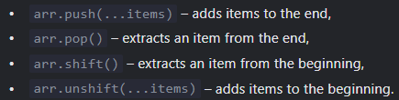**Add/Remove Items**

* Arr.splice([start], [number of elements to delete])
* Arr.slice([start], [end])
* Arr.concat(arg1, arg2…)

1. 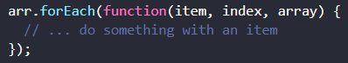**Iterate**

.foreach() sama seperti .map(), bedanya

.foreach() tidak mereturn apapun(hanya perform function pada tiap elemen. biasanya hasil perform functionnya ada dalam function tsb.

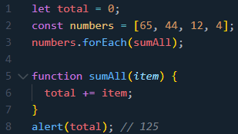.map() mereturn array baru(hasil perform function pada tiap elemen)

1. **Searching**

* indexOf() / lastIndexOf() and includes()

indexOf() : return index of element(first match)

lastIndexOf() : return index of element(last match)

includes() : return true if array includes(menyertakan) the element

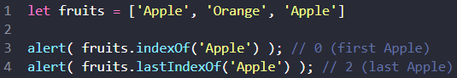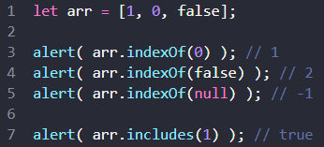

* find() and findIndex() / findLastIndex()

find() : return first element that match the function.

findIndex() : return index of first element that match the function.

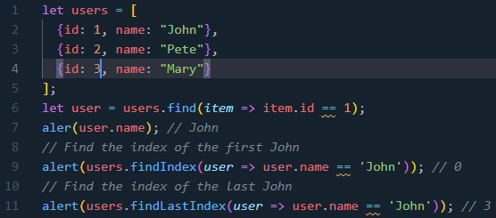findLastIndex() : return index of lasat element that match the function.

* filter() : return (all) element that match the function

1. **Check isSome(true) & isEvery(true)**

* some() : to check atleast 1 element match the function
* every() : to check if function return true for all elements. in other words, executes a function for each array element. returns true if the function returns true for all elements.

1. **Transform an array**

* map(function(currentValue, index, arr), thisValue) : (creates new array)performing function to every array element.

Example at **Rangkuman Object Basics sub-bab E**

* sort() : mengurutkan elemen-elemen dalam sebuah array(sesuai urutan karakter Unicode).

Example at **Rangkuman Object Basics sub-bab E**

* reverse() : reverses the order of elements (in array).
* split() & join()
* split(*separator, limit*) : splits a string into an array of substrings. If *separator* omitted, an array with the original string is returned. *limit* means An integer that limits the number of splits.
* join(*separator*) : joins all array elements into a string(you can specify the separator).
* reduce() & reduceRight()
* reduce() : (creates new array) returns a single value(the function's accumulated result). This method is very useful for various operations such as adding values, multiplying values, combining objects, and so on.

Example at **Rangkuman Object Basics sub-bab E**

* reduceRight() : does the same but goes from right to left.

1. **Spread Operator (‘…’)**

( … ) expands an iterable (like an array) into more elements. This handy **to copy** all or parts of an existing **array** into another array.

****Example: copy entire array

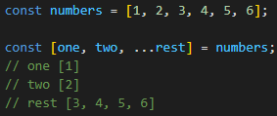Example: copy parts of array

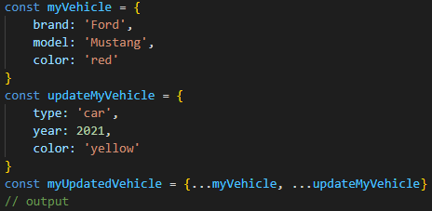Example: in object

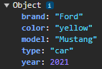

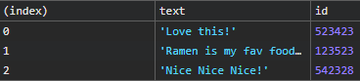Spread operator (...) menyebarkan elemen-elemen dari array menjadi elemen-elemen individu, sedangkan tanpa operator spread, array tersebut dimasukkan sebagai elemen tunggal dalam array baru.

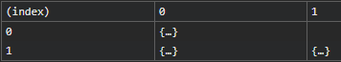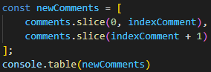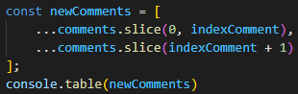sedangkan

1. **Additional**

* 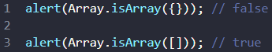isArray() : to check if it is array
* 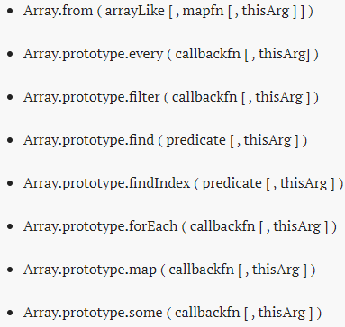thisArgs / thisValue

Banyak array method yang menggunakan thisArg sebagai parameter keduanya.

This is what the second argument does, thisArg, assigns value for ‘this’ object.

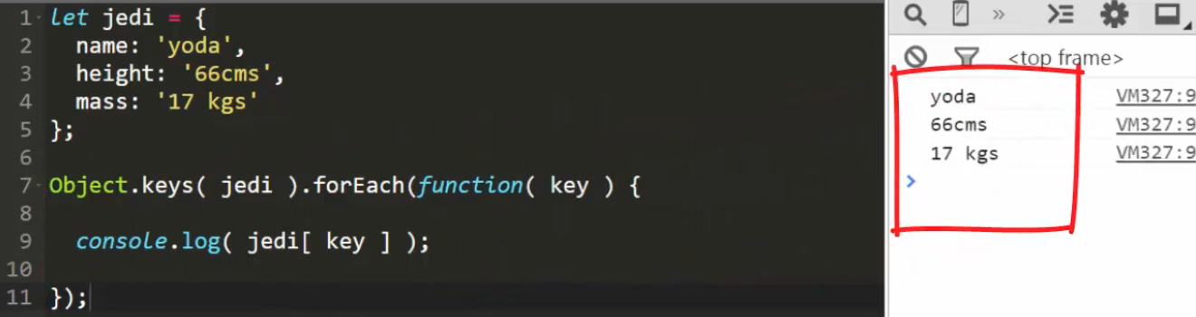jadi parameter kedua merupakan nilai dari ‘this’. Berikut contohnya:

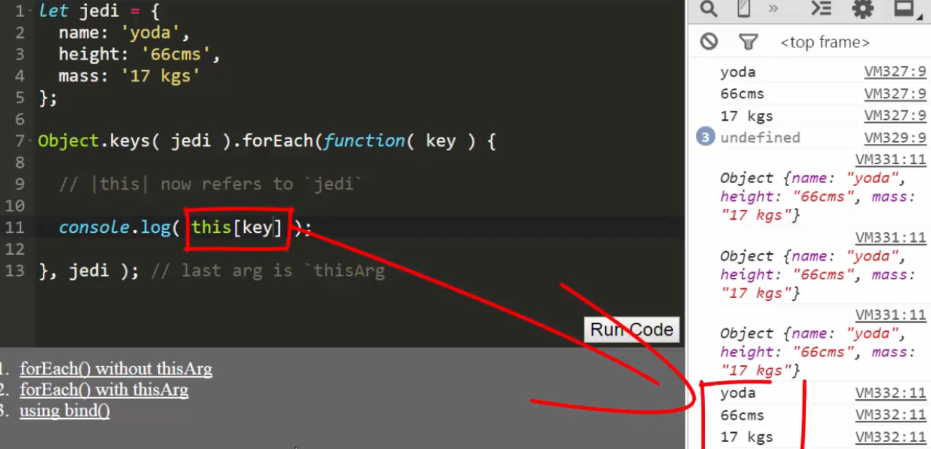kode di bawah ini sama artinya dengan kode yang di atas^